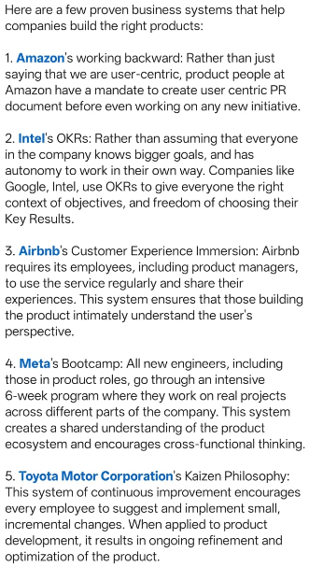.

Question: "Which of these five product systems—Working Backward, OKRs, User Immersion, Cross-Functional Boot camps, or Kaizen—would you implement first in an early-stage product team, and why?"

